1. mlflow --version

Ans : 2.13.0

1. 4 files saved to the output folder

(base) @HemalathaRamanujam2022 ➜ .../output (main) $ ls -al

total 7024

drwxrwxrwx+ 2 codespace codespace 4096 May 27 17:05 .

drwxrwxrwx+ 8 codespace codespace 4096 May 27 17:05 ..

-rw-rw-rw- 1 codespace codespace 131004 May 27 17:05 dv.pkl

-rw-rw-rw- 1 codespace codespace 2458696 May 27 17:05 test.pkl

-rw-rw-rw- 1 codespace codespace 2374516 May 27 17:05 train.pkl

-rw-rw-rw- 1 codespace codespace 2215822 May 27 17:05 val.pkl

3.

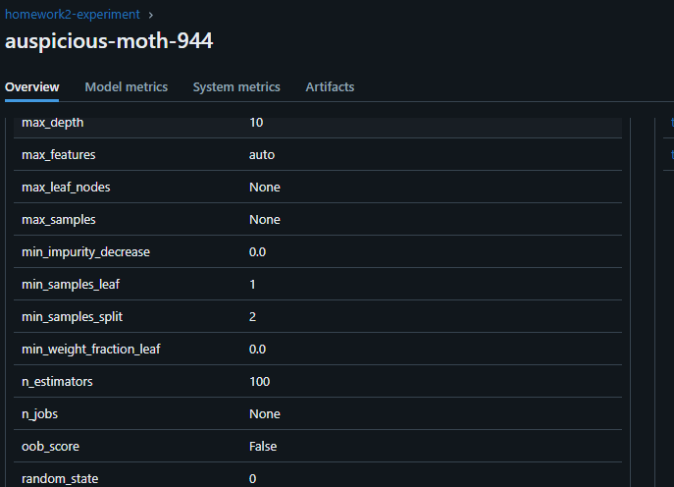

4.

default-artifact-root

5.

(base) @HemalathaRamanujam2022 ➜ .../02-experiment_tracking (main) $ python homework/hpo.py

2024/05/28 18:37:30 INFO mlflow.tracking.fluent: Experiment with name 'random-forest-hyperopt' does not exist. Creating a new experiment.

100%|████████████████████████████| 15/15 [01:01<00:00, 4.07s/trial, best loss: 5.335419588556921]

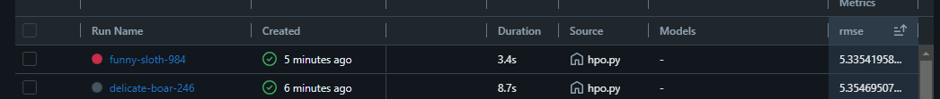

5. racking. Reason: 'numpy.ndarray' object has no attribute 'toarray'

run id: 6354ada468a446aba6ec25802ca81f2b, rmse: 5.5674

run id: 0f22595a72ef4f0bb50ea757124644a0, rmse: 5.5853

run id: bea602d5118949039850aedef0af4737, rmse: 5.5895

run id: b892d49fc508459e9148a8e538de1cbd, rmse: 5.5921

run id: 03ef9771663541f6b7221b0d7822fafe, rmse: 5.5942

